

**FPT ACADEMY INTERNATIONAL**

**FPT – APTECH COMPUTER EDUCATION**

**VIRUSES**

|  |  |  |  |
| --- | --- | --- | --- |
| **Center Name** | | ACE-HCMC-2-FPT  Address: 590 Cach Mang Thang Tam, District 3, Ho Chi Minh City | |
| **Instructor** | | Mr. Nguyen Van Binh | |
| **Class** | | T1.2005.E3 | |
| **Group** | | 2 | |
| **Group members** | | **Name** | **Student ID** |
| Dang Hoang Huy | Student1268269 |
| Nghe Thanh Loi | Student1268265 |
|  |  |
| **Duration** | **Start date** | 1st August 2020 | |
| **End date** | 1st Sept 2020 | |

**This is to certify that**

**Mr./Ms.:**

Dang Hoang Huy

Nghe Thanh Loi

**has successfully designed & developed**

eProject: Viruses

**Submitted by:**

Nghe Thanh Loi

**Date of issue:**

**Authorized Signature:**

**TABLE OF CONTENTS**

ACKNOWLEDGEMENT 3

SYNOPSIS 4

PROBLEM STATEMENT 5

CUSTOMER'S REQUIREMENTS SPECIFICATIONS 6

SCOPE OF THE WORK (IN BRIEF) 7

ARCHITECTURE AND DESIGN OF THE SYSTEM 7

DIAGRAM OF THE WEBSITE 8

SITE MAP 10

MOCK OF THE WEBSITE 11

1. Home page 11

2. About Us 12

3. Type of Virus 13

4. Year wise Listing 14

5. Contact us

WEBSITE DESCRIPTION 17

1. Home page : Show some images of viruses and generanfomation 17

2. About Us : Infomation about our company and our target,misson when made this site 18

3. Type of Virus :Beside some general info already showed in homepage,provide more knowledge about specific type of virus 19

4. Year wise listing : Virus 's found year and found location 20

5. Contacts Us : Address,telephone number and contact method 21

# 

# ACKNOWLEDGEMENT

It is often said that “Gratitude is the sign of noble souls”. That’s why we devote this chapter to express our deep gratitude towards those who have supported and guided us to accomplish this e-Project successfully.

First and foremost, we strongly appreciate the invaluable assistance that our beloved instructor – Mr. Nguyen Van Binh, has offered us. Whenever problems come up, he’ll always the one that we can count on for solutions. Anytime when our team chose a wrong way, Mr. Binh gave us a pep talk to keep us back on the track. Therefore, once again, we truly value your dedication and guidance, Mr. Nguyen Van Binh.

Next, it would have been impossible to carry out and complete this project without the collaboration among our team members. Although we have gone through many obstacles during the project implementation, eventually we gained what we aimed at by our hard work, our strong commitment and of course, our friendship.

Finally, thanks to this e-Project assignment, we had a golden opportunity to apply what we have learnt into reality and gain hands-on experience which is essential for our future career.

# SYNOPSIS

Viruses have caused major damage to mankind. In recent times there are various Viruses which have attacked humans. The information about these viruses is scattered. There is need to develop a website with complete and relevant information about these viruses.

Vertex systems wants to develop a website with proper information about various viruses. Their attack on human system with proper symptoms, precautions and relevant cure (if available).

The website which they demand is supposed to provide user friendly environment and navigation. The important menu must be stated in the top section of the webpage. Also a decent look out and color combination is expected.

The website is to be developed for the Windows Platform using HTML5, JavaScript and Geolocation. The site should work well in all leading browsers including Chrome, IE, Firefox etc.

# PROBLEM STATEMENT

# 

# CUSTOMER'S REQUIREMENTS SPECIFICATIONS

1. **Client: Virus Information** website
2. **Business/Project Objective:**

VERTEX SYSTEM is making a site that can provide information about kinds of viruses and all useful information about diseases, location, symptoms etc. In order to mankind have more knowledge about diseases and those’s cause to now.

1. **Input to the system:**

* **From webmaster:**
* Information about kinds of Virus.
* **From web users:**
* Searching for specific kind of virus.
* **Output from the system:**
* Provide many information as possible about searched virus.
* Disease cause by virus.
* First found location, Researcher .etc.

1. **Hardware/ Software Requirements**

* **For webmaster**

**Hardware**

* Intel Pentium 4 processor or higher
* 1 Gigabytes of RAM or higher

**Software**

* Windows 7 OS or higher
* Visual Studio Code and Webstorm
* HTML5 and Javascript supporting web browsers such as IE, Chrome or Firefox
* **For web users**

**Hardware**

* Intel Pentium 4 processor or higher
* 512 Megabytes of RAM or higher

**Software**

* Windows XP OS or higher
* HTML5 and Javascript supporting web browsers such as IE, Chrome or Firefox

# SCOPE OF THE WORK (IN BRIEF)

A long and detailed discussion, our group has decided to create a website contain the following webpages After:

1. ***Homepage***: Display general information about some kinds of Viruses
2. ***About Us***: Information about website provider
3. ***Type of Virus***: More specific about virus
4. ***Year wise list*** : Worldwide published year and found location .
5. ***Contact Us***: Provide Contact Form , Maps.

# 

# ARCHITECTURE AND DESIGN OF THE SYSTEM

Webpage request

**WEB BROWSER**

**WEB SERVER**

Requested Page

**RENDERING ENGINE**

INTERPRETATION

INTERPRETATION

# 

# DIAGRAM OF THE WEBSITE

**HOME (index.html)**

**About Us(About Us.html)**

**Type of Virus(Content.html)**

**Contact Us(Contact.html)**

**TASK SHEET REVIEW 1**

|  |  |  |  |  |  |  |  |
| --- | --- | --- | --- | --- | --- | --- | --- |
| **Project Ref. No.:**  **eP/Advertisement** **Portal Management** **System/01** | | **Project Title:** | **Activity Plan** **Prepared** **By:** | **Date of Preparation of Activity Plan:** | | | |
| **Sr.No.** | **Task** | **Actual Start** **Date** | **Actual** **Days** | **Team** **Mate** **Names** | **Status** |
| 1 | Work Flow | Viruses | All members | 31/7/2020 | 1 | Huy | Done |
| 2 | Site Map | 31/7/2020 | 1 | Loi | Done |
| 3 | Diagram | 04/08/2020 | 1 | Huy | Done |
| 4 | Document prepare | 04/08/2020 | 1 | Loi | Done |
| 5 |  |  | 1 |  |  |
| 6 |  |  | 1 |  |  |

|  |  |
| --- | --- |
| Date: | |
| Signature of Instructor  **Mr. Nguyen Van Binh** | Signature of Team Leader  **Dang Hoang Huy** |

# 

# SITE MAP

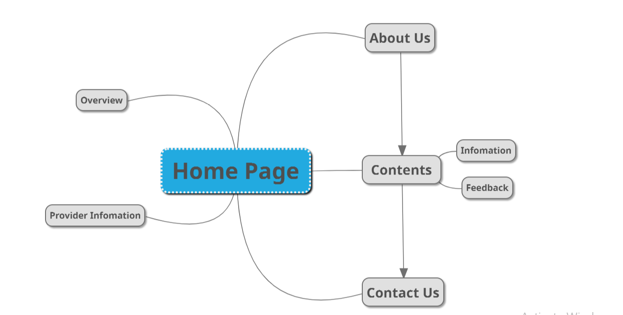

# 

# MOCK OF THE WEBSITE

We divide the website structure into layouts which will be displayed below. The header section includes Aura logo and the Navigation Bar. Some tabs will have the pictures slideshow with the nice animation. The main content of each tab will be displayed in “Content” section. The footer includes Phone, Online Time, Map.

## Home page

**HEADER**

**(LOGO – NAVIGATION BAR)**

**WATCH PRODUCTS**

VIDEO

**FOOTER**

|  |
| --- |
| **Virus4**  **Virus2**  **Virus3**  **Virus6**  **Virus5**  **FOOTER**  **INFOMATION**  **Virus1**  **NAVIGATION BAR**  **HEADER**  **(LOGO)** |

## 2.Type of Virus

**3. About Us**

**HEADER**

**(LOGO – NAVIGATION BAR)**

**CONTENT**

**FOOTER**

**4. Contact Us**

|  |
| --- |
| **CONTACT FORM**  **FOOTER**  **MAP**  **NAVIGATION BAR**  **HEADER**  **(LOGO)** |

**TASK SHEET REVIEW 2**

|  |  |  |  |  |  |  |  |
| --- | --- | --- | --- | --- | --- | --- | --- |
| **Project Ref. No.:**  **eP/Advertisement** **Portal Management** **System/01** | | **Project Title:** | **Activity Plan** **Prepared** **By:** | **Date of Preparation of Activity Plan:** | | | |
| **Sr.No.** | **Task** | **Actual Start** **Date** | **Actual** **Days** | **Team** **Mate** **Names** | **Status** |
| 1 | Site map | Virus | All members | 22nd Aug | 1 | Huy | Completed |
| 2 | Mock of the website | 22nd Aug | 1 | Loi | Completed |
| 3 | Task sheet | 22nd Aug | 1 | Loi | Completed |

|  |  |
| --- | --- |
| **Date:** | |
| Signature of Instructor:  **Mr. Nguyen Van Binh** | Signature of Team Leader:  **Dang Hoang Huy** |

# WEBSITE DESCRIPTION

At this time, our group has just completed some main parts of Virus.com such as homepage, type of virus, about us and contacts. The content and design of the website currently are not the final official version, so they may not have the most beautiful appearance.

## Home page

1. ***Description:***Display general information about Virus with video in order to attract users in the best way. The navigation bar with all tabs to link to pages of the website such as About Us, Type of Virus and so on. Below the navigation bar, the video automatically playing and the users can control it as well. After that, some general information about us is showed. Last but not least, the footer includes Phone Number, Mail, Maps, Contact Address.
2. ***Navigation bar:*** This menu bar allows users to navigate to every webpage of the whole website. For example, users need to click on “Contacts Us” so the Contact Us page will open. The same method is applied for other pages.
3. ***Screenshot:***

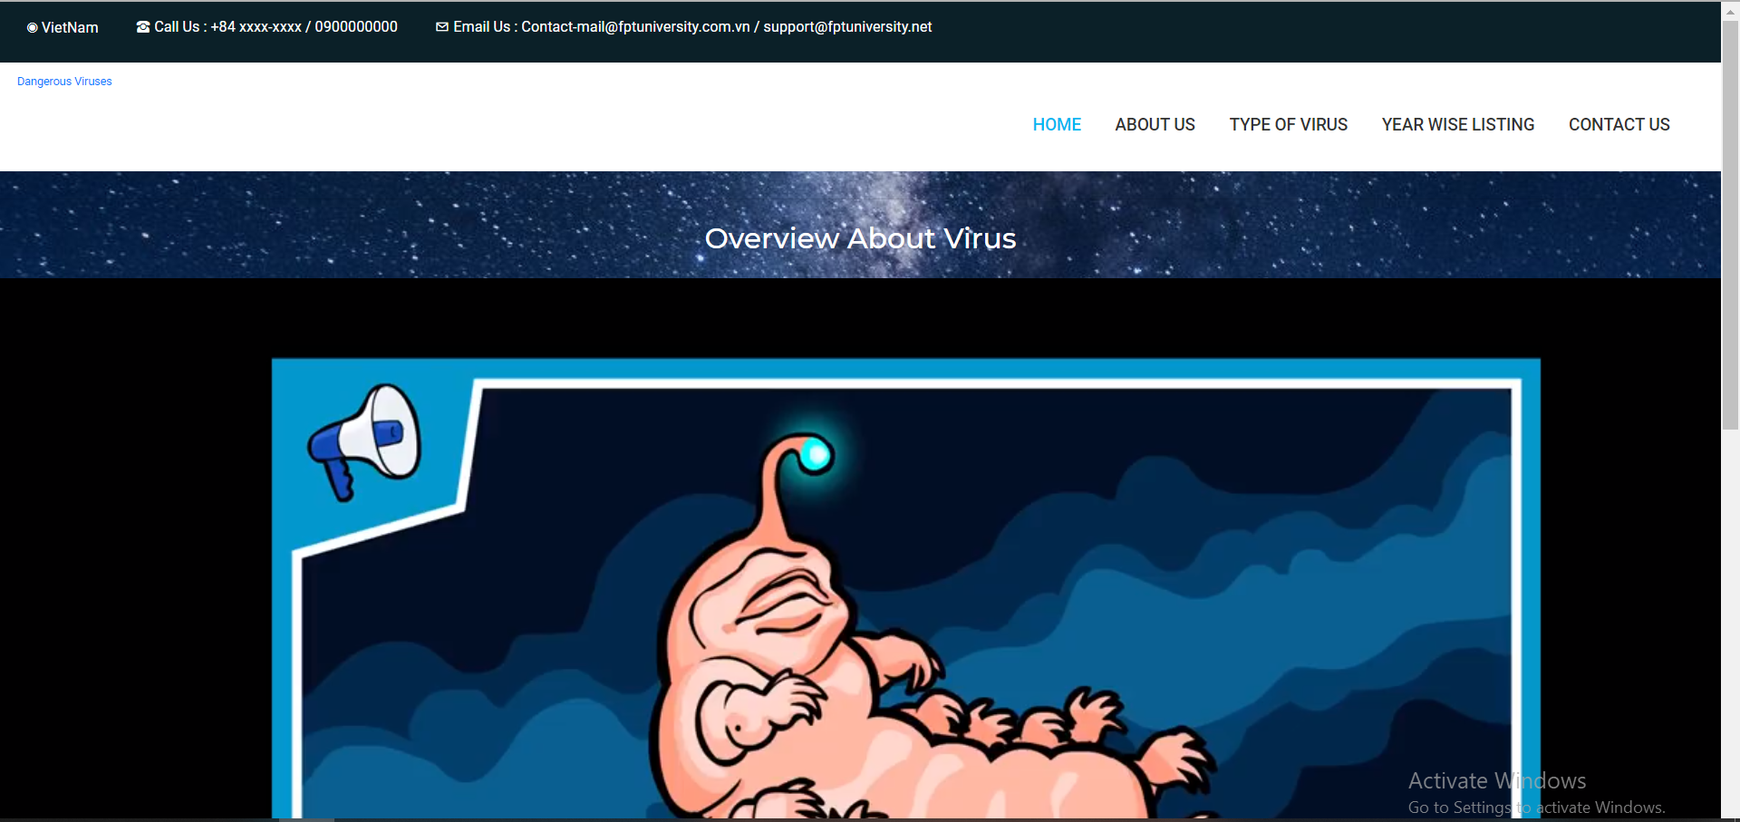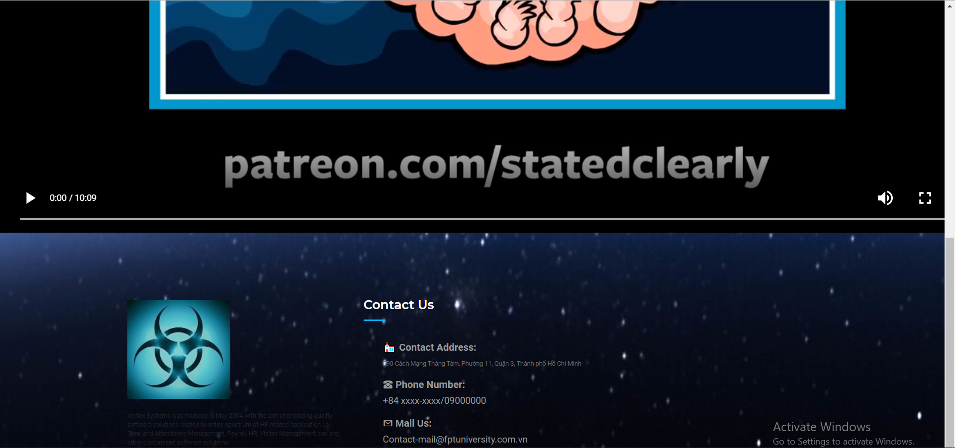

***2.About Us***

1. ***Description*:** Display member of this project with detail information including pictures.
2. ***Screenshot:***

**3.*Type of Virus***

1. ***Description****:* This page is showing nine most dangerous viruses in the world including detail about it (years, location,…) with the image of each type.
2. ***Screenshot:***

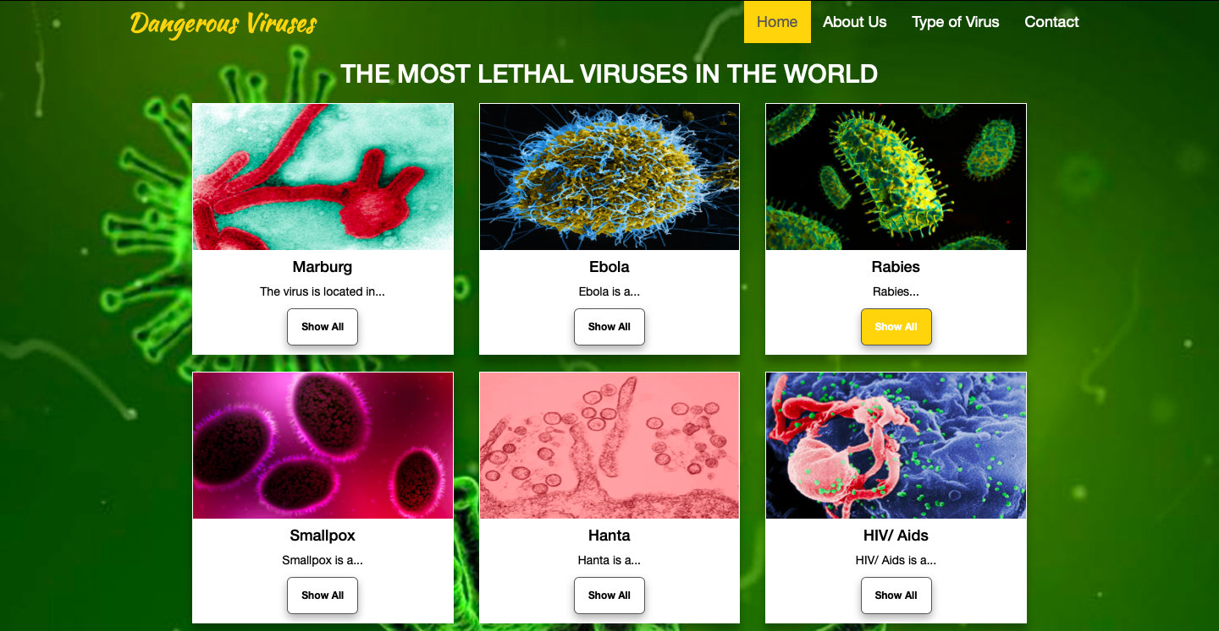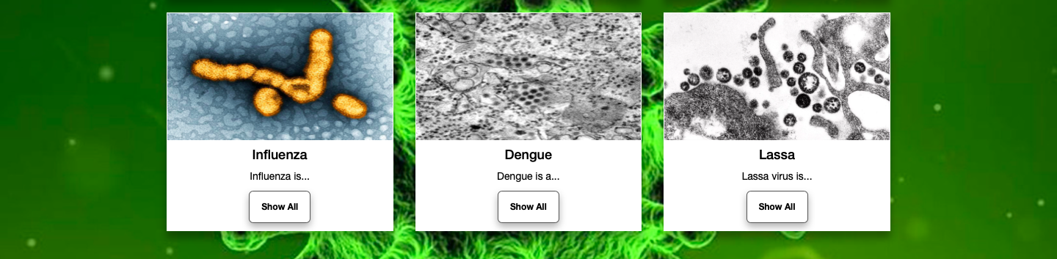

**3.Contact Us**

* 1. ***Contact Us***
  2. ***Description****:* This page allowing user can fill information for contacting us including Name, Phone number, Mail, and the messages
  3. ***Screenshot:***

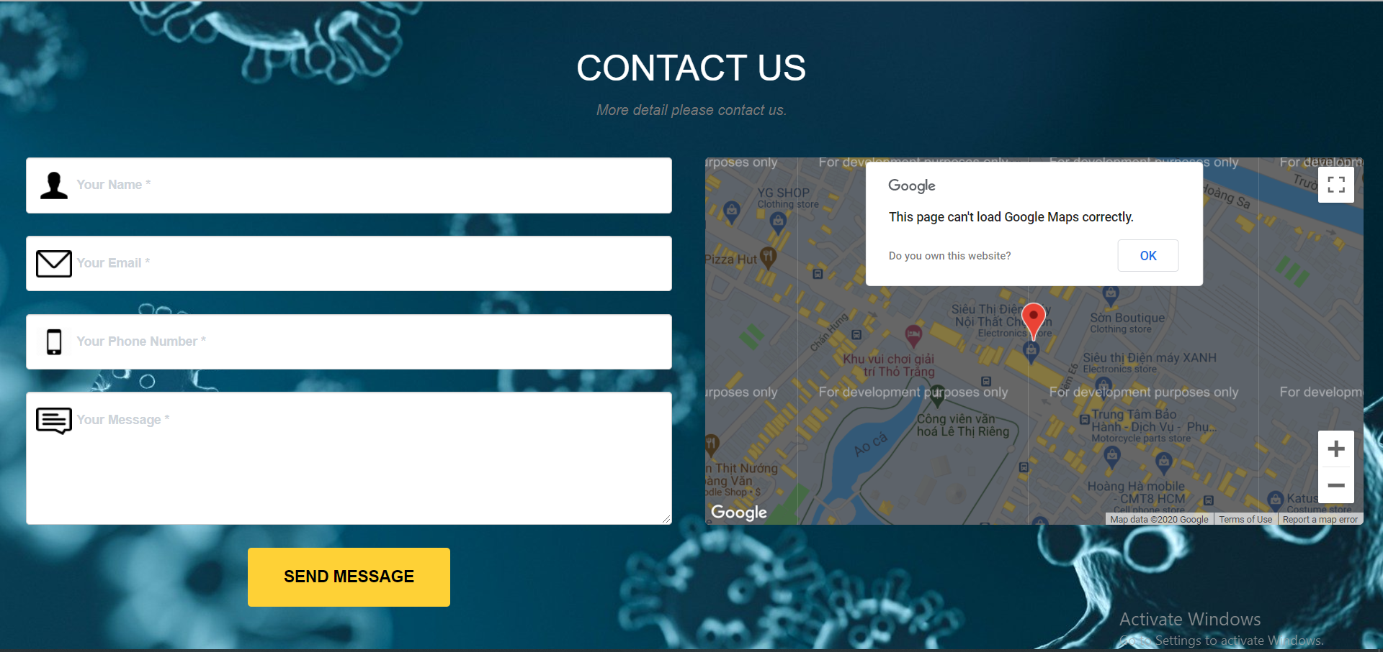

**TASK SHEET REVIEW 3**

|  |  |  |  |  |  |  |  |
| --- | --- | --- | --- | --- | --- | --- | --- |
| **Project Ref. No.:**  **eP/Advertisement** **Portal Management** **System/01** | | **Project Title:** | **Activity Plan** **Prepared** **By:** | **Date of Preparation of Activity Plan:** | | | |
| **Sr.No.** | **Task** | **Actual Start** **Date** | **Actual** **Days** | **Team** **Mate** **Names** | **Status** |
| 1 | Home page, Header, Footer. | Viruses |  | 15/Aug |  | Huy | Completed |
| 2 | About Us | 15/Aug |  | Huy | Completed |
| 3 | Contact Us | 15/Aug |  | Loi | Completed |
| 4 | Types of Virus | 15/Aug |  | Loi | Completed |
| 5 | Document(Create) | 20/Aug |  | Huy | Completed |
| 6 | Document(Update) | 22/Aug |  | Loi | Completed |

|  |  |
| --- | --- |
| **Date:** | |
| Signature of Instructor:  **Mr. Nguyen Van Binh** | Signature of Team Leader:  **Dang Hoang Huy** |